**Literacy**

|  |  |
| --- | --- |
| Monday 29th June 2020 | The main aim of this week is to continue to practice their writing skills.  Read the story ‘Seal Surfer’ and discuss the book with your child. What did they like or dislike about the story? Can your child write some sentences about why they liked or disliked the story? They can mention what parts of the story they liked and which parts they did not like.  Seal Surfer: <https://www.youtube.com/watch?v=F02vU-w6BiA>  (We apologise about the quality of the video) |
| Tuesday 30th June 2020 | Talk about the story once more. Get your child to draw three images of what happened in the story and include a caption(short sentence to describe the picture) |
| Wednesday 1st July 2020 | Look at the picture below. Get your child to write some sentences about the image from the story ‘Seal Surfer’. |
| Thursday 2nd July 2020 | Get your child to research seals. What can they find out? Get them to make a simple fact file about what they find out. They can include some pictures and they can write some simple sentences. |

**My thoughts about ‘Seal Surfer’**

___________________________________________________________________________

___________________________________________________________________________

___________________________________________________________________________

___________________________________________________________________________

___________________________________________________________________________

___________________________________________________________________________

___________________________________________________________________________

___________________________________________________________________________

___________________________________________________________________________

___________________________________________________________________________

**Writing captions**

|  |  |  |
| --- | --- | --- |
|  |  |  |
|  |  |  |

.

**Describing a picture**

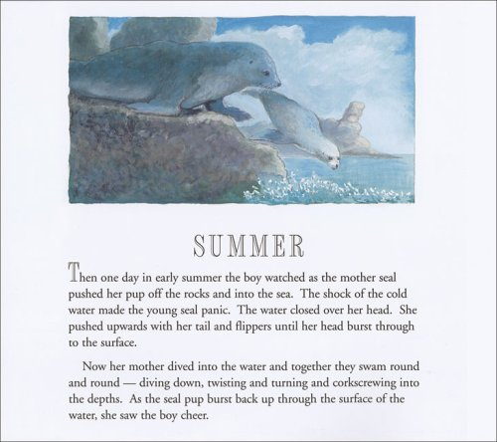

___________________________________________________________________________

___________________________________________________________________________

___________________________________________________________________________

___________________________________________________________________________  
  
___________________________________________________________________________

___________________________________________________________________________

___________________________________________________________________________

___________________________________________________________________________

___________________________________________________________________________

___________________________________________________________________________

___________________________________________________________________________

**Fact file**

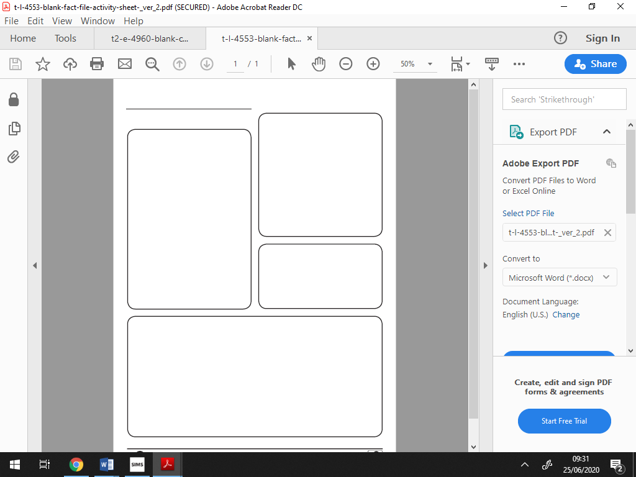

**Literacy - Week commencing 6th July 2020**

Here are a range of literacy activities to do.

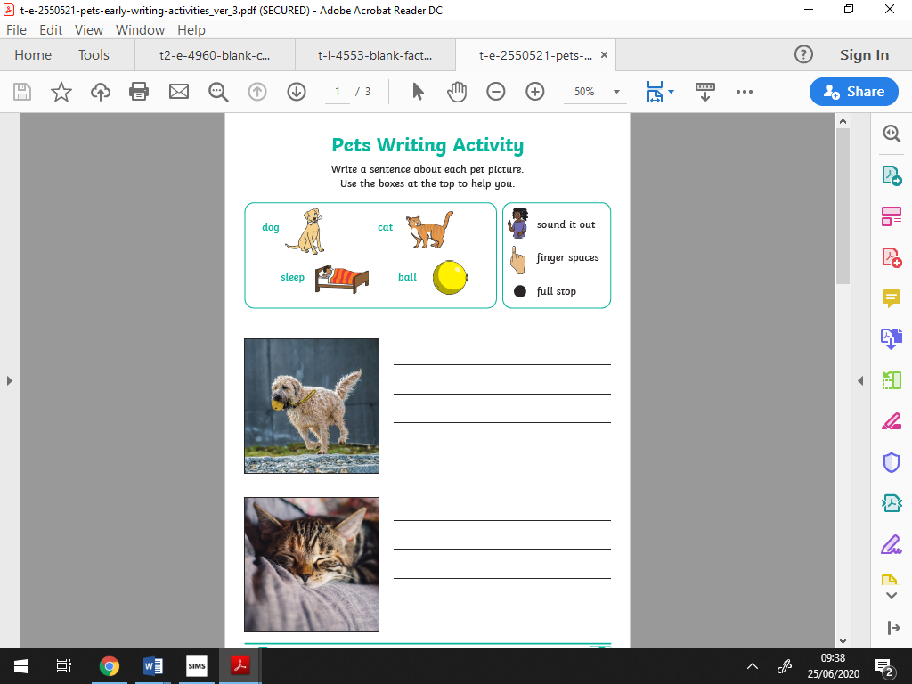

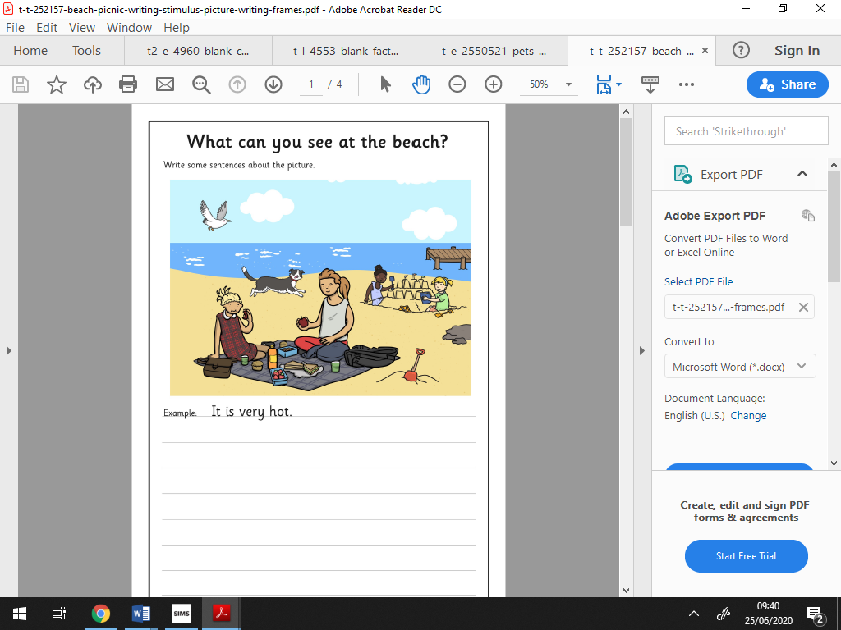





**Maths**

We’ve come to the end of our unit’s for Reception so you all deserve a big well done for working so hard in school and at home! Our last two weeks will focus on consolidating numbers within 20 and counting beyond 20.

|  |  |
| --- | --- |
| Monday | Practice counting to 20 starting from a random number. You can count objects in the house or different cars/trees you see on a walk. Complete the missing number worksheet. |
| Tuesday | Practice solving problems with numbers to 20. Today’s task: Sharing and grouping. Can the children share 20 pieces of food between family members/teddies? Ensure they can recognize how many groups there are and how many are in each group. |
| Wednesday | Practice solving problems with numbers to 20. Complete the Maths activity worksheets and address any problems with the child e.g. how to recognize one more, how to add by counting on. |
| Thursday | Practice solving problems with numbers to 20. Complete the Maths activity worksheets and address any problems with the child e.g. how to recognize one more, how to add by counting on. |

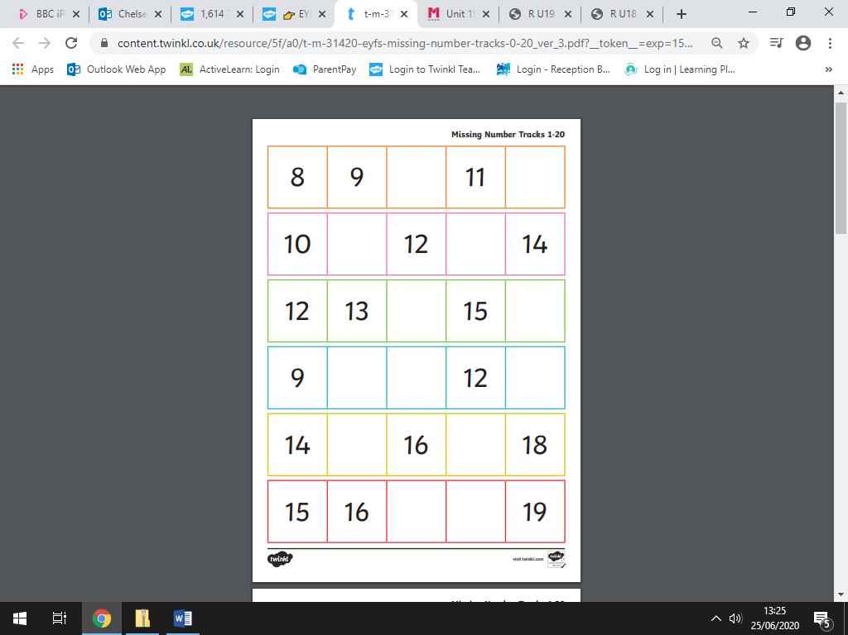

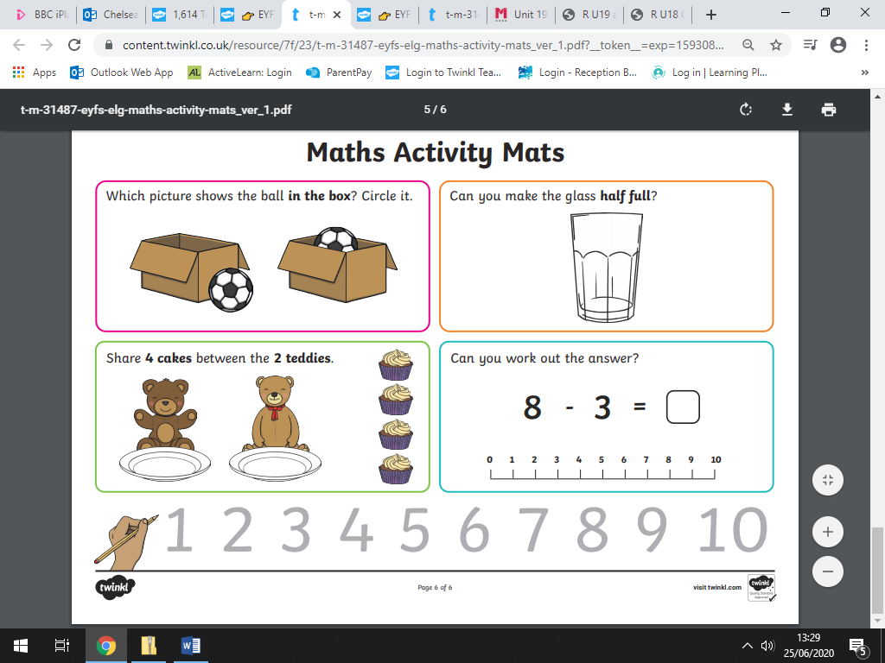

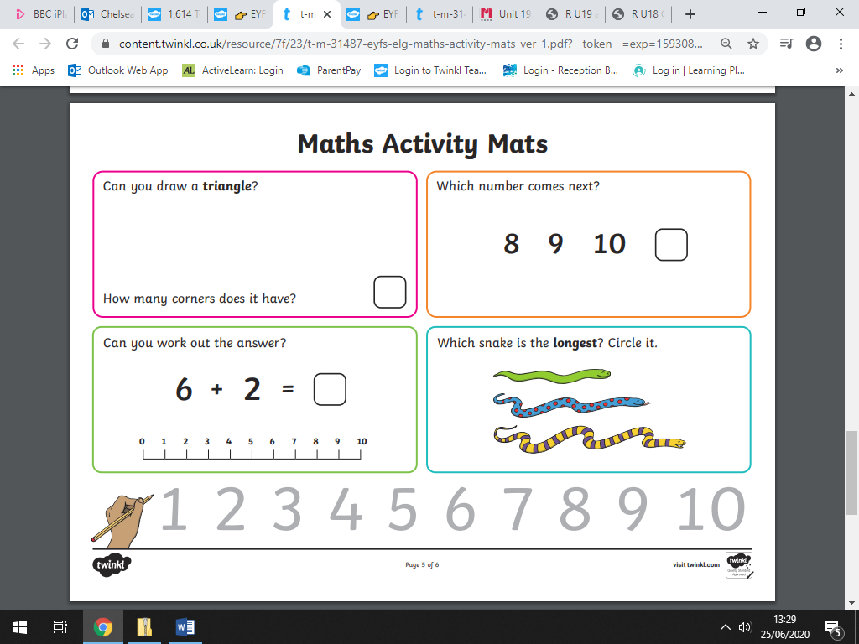

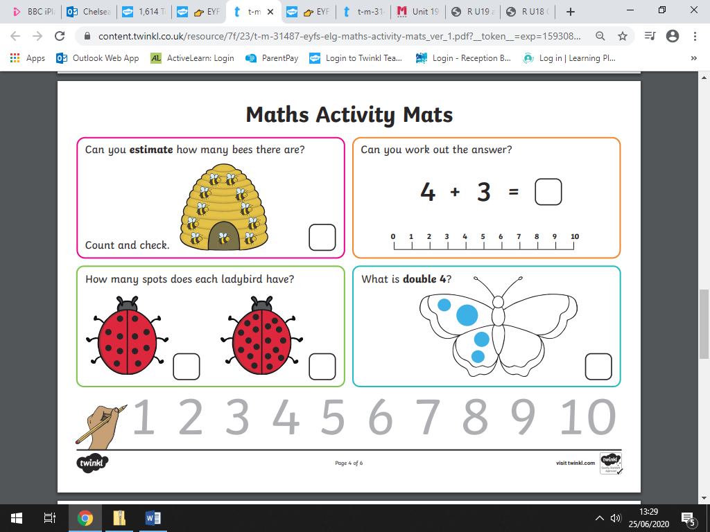

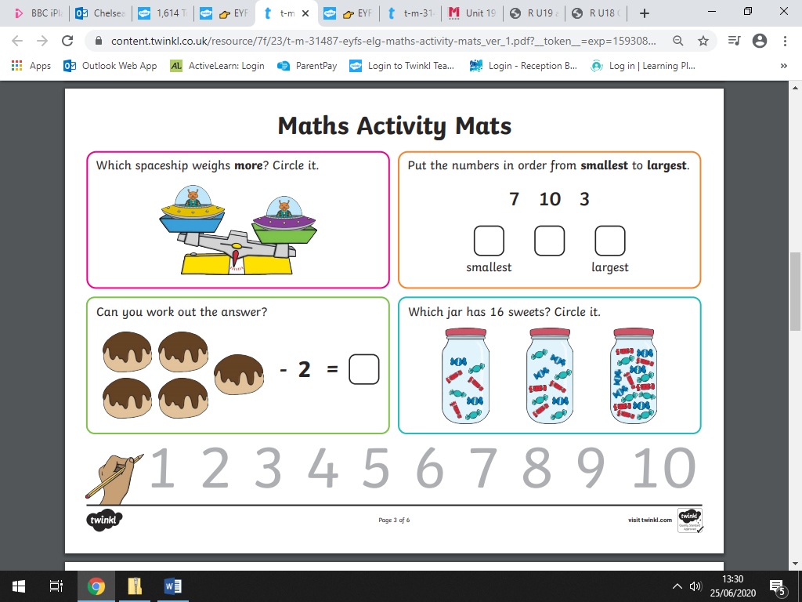

**Maths – Numbers beyond 20.**

|  |  |
| --- | --- |
| Monday | Count to 30 and ensure that children don’t say ‘twenty-ten’. You can use <https://www.primarygames.co.uk/pg2/splat/splatsq100.html> to help your child understand that every time we get to a new 10, both digits change, so the number names change. |
| Tuesday | Practice counting in 10’s so the children get used to the change of digits. Show them the splat square and splat the numbers to count in 10’s. |
| Wednesday | Practice making numbers 20-30 using objects. E.g. use blocks/leaves to make an arrangement of 24 by placing leavings in rows of 10 and the extra by the side. |
| Thursday | Consolidate learning about numbers beyond 20 by counting to 30 or 40 and focus on the understanding that the name of the number changes. |

|  |  |
| --- | --- |
| Phonics | |
| Monday | Practice Phase 2 & 3 sounds + 10 minutes of reading |
| Tuesday | Ask your child to write the phase 2 & 3 sounds from memory + 10 minutes reading |
| Wednesday | Work on any sounds that your child doesn’t know; if they know them all start practicing Phase 4 clusters + 10 minutes of reading |
| Thursday | Practise Phase 3 and 4 sounds/blends by doing the worksheets below |
| Friday | Practise Phase 3 and 4 sounds by doing the worksheets below. |
| Topic | This fortnight’s topic is based around pets. Please see home learning ideas below. |

