Home learning week beginning 2.11.20
Literacy
This week we have been reading the story of the Gingerbread Man. Please read the Powerpoint you can hear the story.
Cut out the pictures below and ask your child to re-tell the story in order. Get your child to write the either the initial sound or the word of what they can see in the picture. 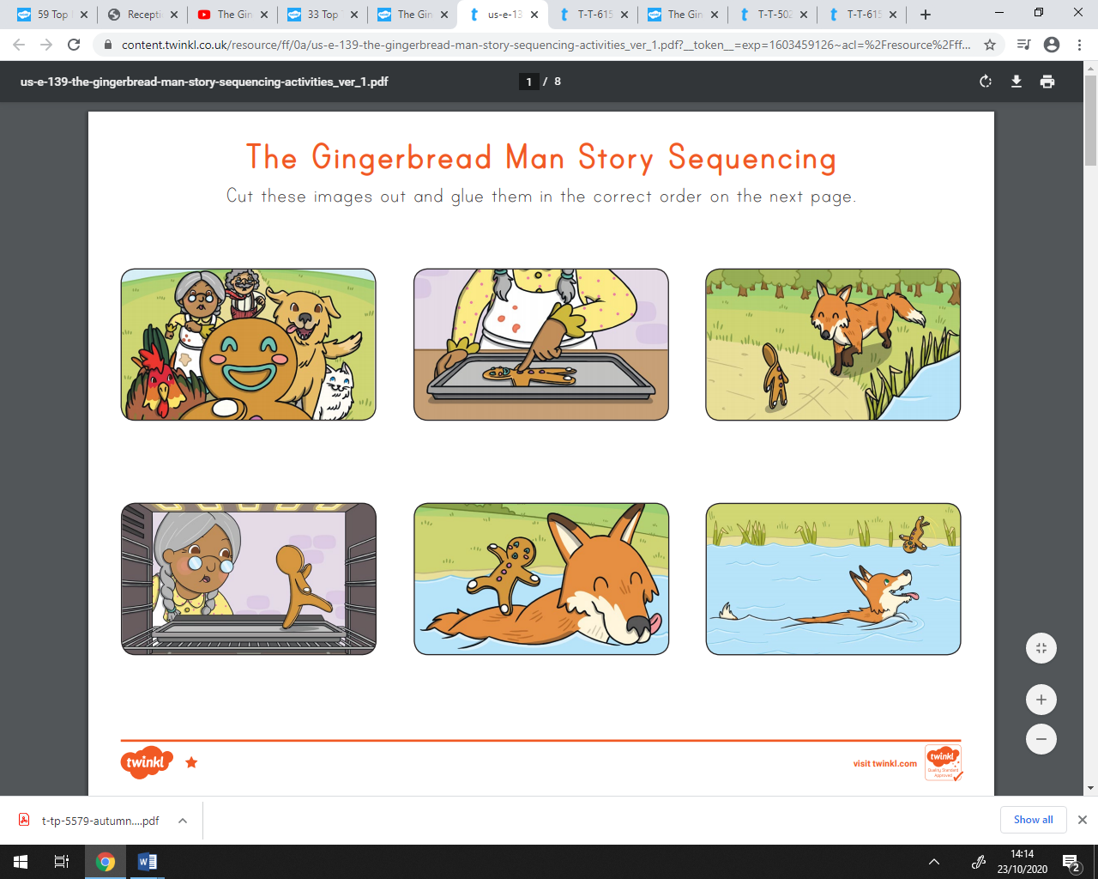
Get your child to design their own gingerbread. Can they write some words to describe it?
Maths
For maths this week, we are working on addition, can you write the total number in the circles.

Please practice this using objects that you have at home, for example, two groups of teddy bears and how many do you have altogether?

Phonics
We will be revising phase 2 sounds and practising writing CVC words.

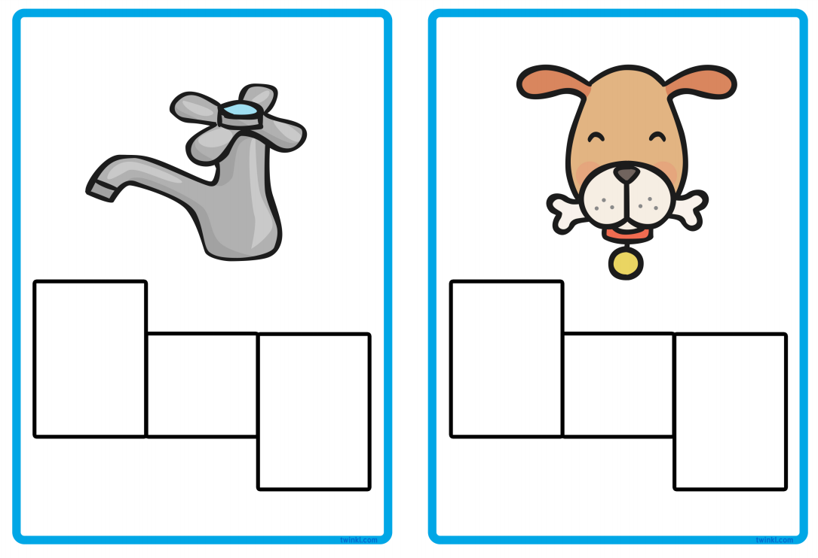
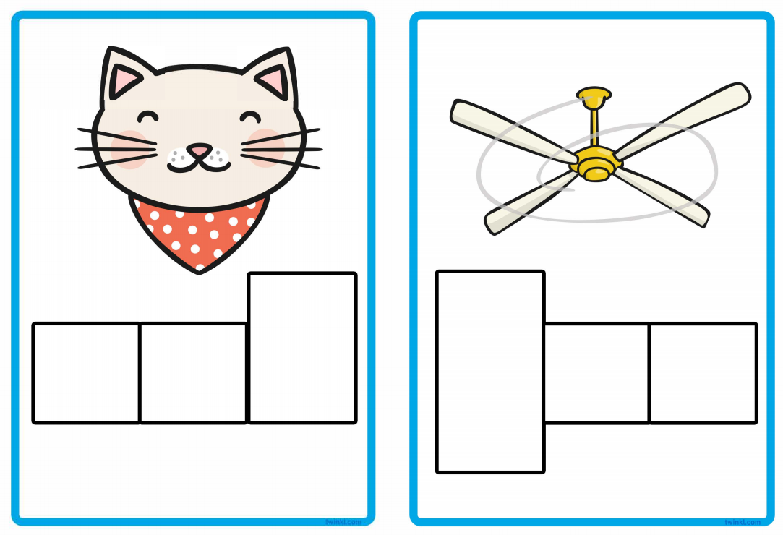
Can you write the word for each picture?

Topic – Bonfire night!
Can you make your own chocolate finger sparkler?

