Computing –
To be introduced to e-books and 2Create a
Story.
To continue a previously saved story.
To add animation to a story.
To add sound to a story, including voice recording and music the children have created.
To work on a more complex story, including adding backgrounds and copying and pasting pages.
To use additional features to enhance their stories.
To share their e-books on a class display board.

Personal, Social and Health Education – Rights and Responsibilities

Children will be able to:
- Recognise the importance of regular hygiene routines.
- Identify what they like about the school environment.
- Demonstrate responsibility in looking after something (e.g. a class pet or plant).
- Explain where people get money from.
- Recognise that different notes and coins have different monetary value.
- Understand the concept of 'saving money'.
- Understanding basic first aid.
Science – Seasonal Changes

- Identify name, draw and label the basic parts of the human body and say which part of the body is associated with each sense.
- Notice that animals, including humans, have offspring which grow into adults.
- Observe closely, using simple equipment.
- To identify and sort different things.
- Gather and record data to help in answering questions.
- To observe changes across the four seasons
- To observe and describe weather associated with the seasons and how day length varies.

Geography- ‘what are the seasons’

In this unit, the children will learn about weather and seasons. This unit has a focus on the local area as well as looking at the wider perspective of the UK. Simply looking out of the window, collecting data in the playground and thinking about what is happening around them, can be perfect ways to support making sense of a changing world. They will observe, spot seasonal patterns and talk about changes by using weather-related vocabulary.
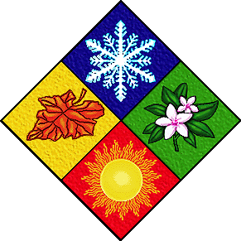
Music – ‘Round and Round'
This is a six-week Unit of Work that builds on previous learning. It is supported by weekly lesson plans and assessment. All the learning is focused around one song: Round and Round, a Bossa Nova Latin style.

Physical Education – Running and Jumping
Children will learn to travel at different speeds by walking, jogging, running and sprinting. All Children will:
• Begin to run at different speeds;
• Move along some basic pathways, for example move in a straight or curved line;
• Begin to use the correct technique for jumping as high and as far as they can;
• Explore different types of jumps;
• Land safely;
• Make a simple sequence of jumps.

Topic Web
Year 2
Spring 2, 2021




Religious Education – ‘Stories of Jesus’

- Describe some of the teachings of a religion
- Describe some of the main festivals or celebrations of a religion
English

The Enormous Turnip
Traditional tales –Talk for Writing.
10 Things found in a Wizards Pocket
Traditional Tales - Poetry

Maths

Adding and Subtracting within 50.

Fractions

Length and Measures

Letters and Sounds

In Phonic Ability Groups

Revision of Phase 2&3

Phase 4, Phase 5
Art – Take One Picture –
- Describe the work of notable artists,
artisans and designers.
- Use some of the ideas of artists studied to
create pieces.
- To master techniques e.g. painting, collage.

